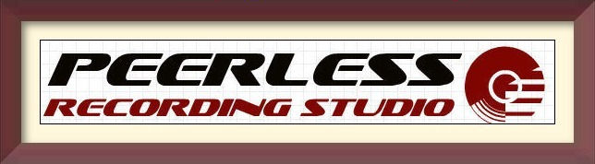

**Most Requested Songs**

*Don't know what songs to have at your event?! Here is a list of the most requested songs as provided by DJ's across the Nation.*

1. Cha Cha Slide......................Mr. C

2. Cupid Shuffle......................Cupid

3. Y.M.C.A. ..........................Village People

4. Electric Slide......................Marcia Griffith

5. Celebration..........................Kool & The Gang

6. Stayin' Alive........................Bee Gees

7. Play That Funky Music.........Wild Cherry

8. Love Shack..........................B-52's

9. Shout..................................Isley Bros.

10. Boogie Shoes.................K.C. & Sunshine Band

11. C'mon Ride It (Train)..........Quad City DJ's

12. Mony Mony.........................Billy Idol

13. I Will Survive.....................Gloria Gaynor

14. Shook Me All Night Long....AC/DC

15. The Twist.........................Cubby Checker

16. Respect.............................Aretha Franklin

17. Brown Eyed Girl................Van Morrison

18. Hokey Pokey.....................Various

19. Chicken Dance...................Various

20. Brick House.......................Commodores

21. Don't Stop Believin'.............Journey

22 Cotton Eyed Joe...................Rednex

23. Ain't No Mountain High Enough...Marvin Gaye

24. Footloose.............................Kenny Logins

25. Old Time Rock & Roll .........Bob Seger

26. I Can't Help Myself...............The Four Tops

27. My Girl...............................The Temptations

28. Single Ladies.........................Beyonce

29. Twist & Shout......................Beatles

30. Time of My Life....................B.Medley/J.Warnes

31. Yeah!....................................Usher

32. Lady Marmalade.................Christina Aguilera & Friends

33. The Way You Look Tonight....Frank Sinatra

34. September.............................Earth Wind & Fire

35. Just Dance.............................Lady Gaga

36. Jump, Jive an' Wail.................Brian Setzer Orchestra

37. Hot In Herre...........................Nelly

38. Baby Got Back.......................Sir Mix-A-Lot

39. Thriller.................................Michael Jackson

40. In Da Club............................50 Cent

41. Kiss.....................................Prince

42. Hey Ya!...............................OutKast

43. Build Me Up Buttercup..........The Foundations

44. Pour Some Sugar On Me......Def Leppard

45. Don't Stop Til You Get Enough...Michael Jackson

46. Low....................................Flo Ridda

47. Sexyback............................Justin Timberlake

48. Dancing Queen....................ABBA

49. You're The One That I Want...Grease

50. We Are Family.....................Sister Sledge